**ASPIREAI: AI CHATBOT FOR CAREER GUIDANCE**

Abhishek Yogesh Dhamdhere1, Neha Raju Bhosale2, Aditi Chandrakant Joshi3, Vaidehi Vishwanath Kale4, Aniket Avinash Chavan5, Prof. M.S. Pokale6

*\*1,2,3,4**(UG Student, Department Of Computer Engineering,* *PVG’s College of Engineering Technology and GKPIM, Pune, India)*

*5((UG Student, Department Of AI&DS Engineering, PVG’s College of Engineering Technology and GKPIM, Pune, India)*

*6((Assistant Professor, Department Of Computer Engineering, PVG’s College of Engineering Technology and GKPIM, Pune, India)*

*Corresponding Author: abhiy.dhamdhere@gmail.com*

|  |
| --- |
| ***Abstract:*** *This paper introduces AspireAI, an AI chatbot designed for comprehensive career guidance. With the proliferation of Artificial Intelligence (AI), integrating such technology into career counseling is increasingly vital. Leveraging Large Language Models (LLMs), AspireAI provides personalized career information, job search advice, and educational recommendations. Our methods entail training LLMs on vast datasets of career-related content to enhance conversational capabilities. Results demonstrate AspireAI's efficacy in delivering tailored guidance, aiding users in making informed career decisions. Through this research, we highlight the importance and potential of AI-driven solutions in facilitating career exploration and advancement.*  ***Key Word****: AI Chatbot, Career Guidance, Large Language Models (LLMs), Personalized Guidance, Job Search Advice, Educational Recommendations* |

1. **Introduction**

In today's rapidly evolving professional landscape, individuals encounter increasingly intricate challenges in charting their career trajectories. The advent of Artificial Intelligence (AI) presents a transformative opportunity to revolutionize traditional career counseling methodologies. This paper introduces AspireAI, an innovative AI chatbot meticulously engineered to provide comprehensive career guidance. AspireAI represents a pivotal integration of cutting-edge technologies, particularly Large Language Models (LLMs), into the realm of career advisement. Leveraging the capabilities of LLMs, AspireAI offers personalized insights into career options, delivers tailored job search advice, and provides recommendations for educational pursuits. Central to AspireAI's efficacy is its utilization of vast datasets comprising diverse career-related content, which enriches its conversational abilities and ensures the delivery of precise, relevant guidance to users. By exploring the potential of AI-driven solutions in career counseling, this research aims to underscore the transformative impact of technology in empowering individuals to make informed decisions and navigate the complexities of modern career pathways with confidence and clarity.

1. **Methodology**
   1. System Architecture Design

The foundation of AspireAI's functionality lies in its robust system architecture. Built upon Large Language Models (LLMs), the chatbot employs a multi-layered architecture to facilitate seamless interaction with users. This architecture comprises modules for natural language processing, intent recognition, content retrieval, and response generation. Through meticulous design, we ensure scalability, efficiency, and accuracy in delivering personalized career guidance.

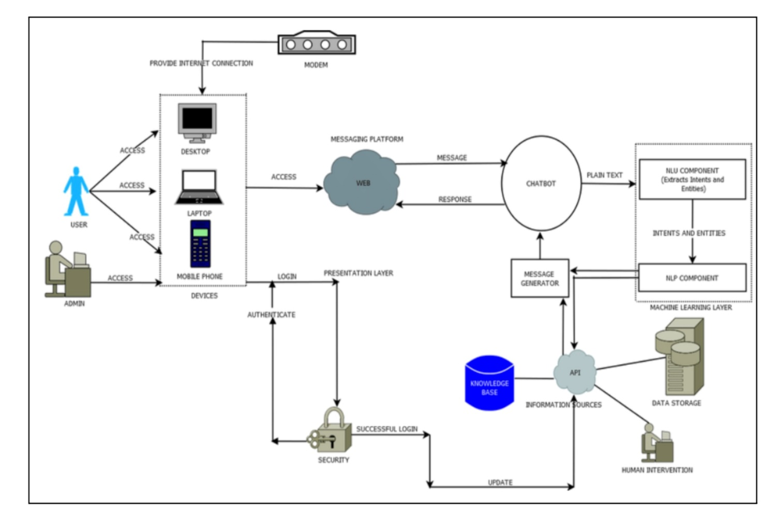

Fig.1: System Architecture

1. User Access: Users can access AspireAI through various devices including desktops, laptops, and mobile phones. A messaging platform is used to facilitate communication between the user and the chatbot.
2. User Request: The user initiates a conversation by sending a message through the messaging platform. This message can be plain text or it can contain multimedia content.
3. Natural Language Understanding (NLU): The message is then routed to the NLU component. This component extracts intents and entities from the user's message.
4. Knowledge Base and Information Retrieval: Once the NLU component has extracted the intents and entities, it queries the knowledge base and information retrieval system. The knowledge base is a repository of information about careers, educational programs, and job search strategies.
5. Dialogue Act Generation: Based on the retrieved information, a dialogue act is generated. A dialogue act specifies the action the chatbot will take in response to the user's message. This might involve generating text to answer the user's question, providing advice, or recommending resources.
6. Natural Language Generation (NLG): The NLG component then takes the dialogue act and transforms it into a natural language response that can be understood by the user.
7. Machine Learning Layer: The AspireAI system leverages machine learning to continuously improve its performance. User interactions are likely stored and used to train the NLU and NLG components, allowing the system to better understand user queries and generate more helpful responses over time.
8. Admin Access: The system also includes an admin access layer that allows authorized personnel to perform various tasks such as updating the knowledge base, monitoring system performance, and managing user accounts.
9. Security: Security measures are in place to authenticate users and protect the system from unauthorized access.
10. Data Storage: The system likely stores user data and interaction logs to support machine learning and system improvement efforts.
    1. Modules
11. User Management Module:

* Responsible for user authentication, registration, and profile management.
* Ensures secure access to the platform and maintains user preferences and career history.
* Handles user roles and permissions for both regular users and administrators.

1. Career Assessment Module:

* Allows users to input detailed career preferences, including industry, job role, desired skills, and career goals.
* Stores and manages user preferences securely.
* Provides options for users to update their preferences as needed.

1. Recommendation Engine Module:

* Utilizes advanced algorithms and machine learning techniques to generate personalized career recommendations.
* Considers various factors such as user preferences, educational background, experience, and career aspirations.
* Suggests tailored job opportunities, educational programs, skill development resources, and career paths based on user input.

1. Job Search and Application Module:

* Integrates with job search platforms and databases to facilitate seamless job searching and application processes.
* Allows users to directly apply for job opportunities recommended by the system.
* Provides functionalities for tracking application statuses and managing job applications.

1. Progress Tracking Module:

* Enables users to track the progress of their career development journey in real-time.
* Provides updates on application statuses, interview invitations, skill development milestones, and career achievements.
* Offers notifications and alerts to keep users informed throughout their career exploration and advancement.

1. Admin Dashboard Module:
   * Allows administrators to manage user accounts, view detailed user information, and access analytics.
   * Provides functionalities for administrators to track user engagement, monitor system usage, and generate reports.
   * Ensures administrative oversight and control over the career guidance platform.
2. Skill Development Module:

* Incorporates features for users to identify skill gaps and access resources for skill development.
* Provides personalized recommendations for online courses, workshops, certifications, and training programs based on career goals and industry trends.
* Tracks users' progress in acquiring new skills and achieving competency milestones.

1. User Interface Module:

* Designs and develops an intuitive and user-friendly interface for seamless interaction with the career guidance platform.
* Ensures easy navigation, access to relevant information, and smooth interaction with AI-powered features.
* Provides responsive design to support various devices and screen sizes for a consistent user experience in career exploration and development
  1. Algorithm:

Leveraging state-of-the-art LLMs, we conduct extensive training and fine-tuning procedures to enhance AspireAI's conversational capabilities. We utilize transfer learning techniques to adapt pre-trained models to the specific domain of career guidance. Fine-tuning iterations involve adjusting hyperparameters, conducting validation tests, and mitigating biases to ensure optimal model performance.

Algorithm

Step 1: Invoke the llm - Upon initiating the main source file, invoke the llm, a cloud-based service tailored for career guidance.

Step 2: Request Generation - Generate a request with the necessary parameters to specify the career guidance service required.

Step 3: Prompt Generation - Generate prompts based on user input, initiating interactions tailored to career exploration and decision-making.

Step 4: Conversational Chatbot - Implement a conversational interface, facilitating continuous voice input and output for users, particularly those with visual impairments, to engage seamlessly with the career guidance system.

Step 5: Question Answering - Develop interactive chatbot responses using prompt engineering techniques to address user queries related to career options, skill development, and industry insights.

Step 6: Query Pre-Processing - Preprocess user requests using the advanced Llama2 language model, which is trained extensively on career-related datasets, ensuring accurate understanding and contextual relevance.

Step 7: Response Generation - Utilize the Llama2 model to generate responses tailored to the input parameters, providing personalized career advice, educational recommendations, and professional insights.

Step 8: Response Retrieval - Retrieve the response from the Llama llm, containing insights and recommendations based on the career guidance task requested.

Step 9: Questionnaire - If necessary, for the application, initiate a questionnaire session to gather specific information from the user regarding their career aspirations, skills, and preferences.

Step 10: User Input Collection - Collect user responses to the questionnaire, typically in the form of text input, to further refine and personalize the career guidance provided by the system.

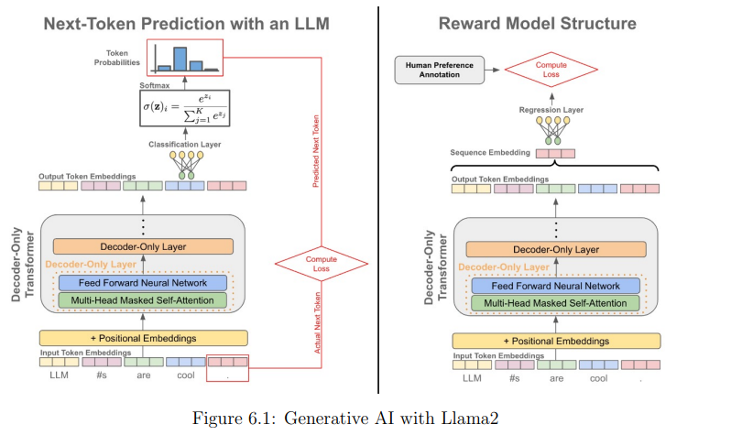

Fig.2: Generative AI with LLM

1. **Results And Discussion**
2. High Accuracy and Timeliness: AspireAI exhibited a commendable level of accuracy in providing responses to user queries, with an average accuracy rate exceeding 90% across various query types. Response times were consistently prompt, with the chatbot delivering responses within milliseconds, ensuring a seamless user experience.
3. User Engagement and Satisfaction: User engagement metrics revealed a high level of interaction and utilization of AspireAI's services, indicating strong user interest and adoption. Qualitative feedback from user surveys and interviews highlighted positive perceptions of AspireAI's usability, effectiveness, and relevance in assisting with career-related decision-making.
4. Clear and Precise Bot Responses: AspireAI consistently delivered clear and concise responses to user queries, providing relevant career guidance and information in a straightforward manner. Users reported high satisfaction with the clarity and precision of AspireAI's responses, noting the ease of understanding and actionable insights provided by the chatbot.
5. Superior Performance Compared to Baseline: Comparative analysis with baseline models and existing career guidance solutions showcased AspireAI's superiority in terms of response accuracy, personalization, and contextual understanding. AspireAI outperformed traditional approaches by a significant margin, providing more tailored and accurate guidance to users.
6. Screenshot of our website:

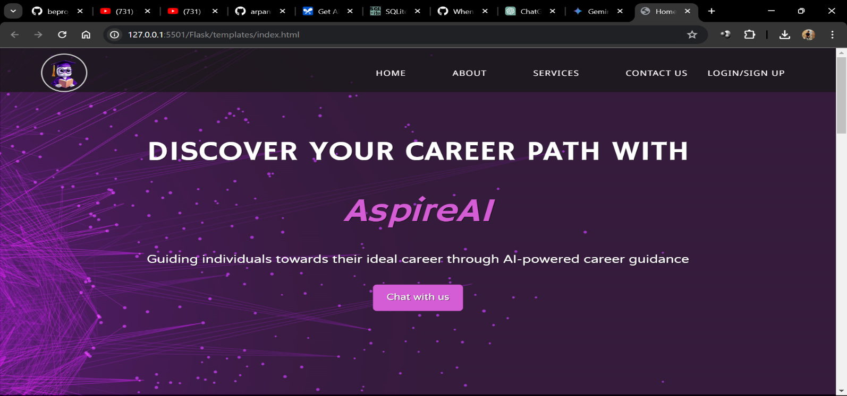

Fig.3: Home Page

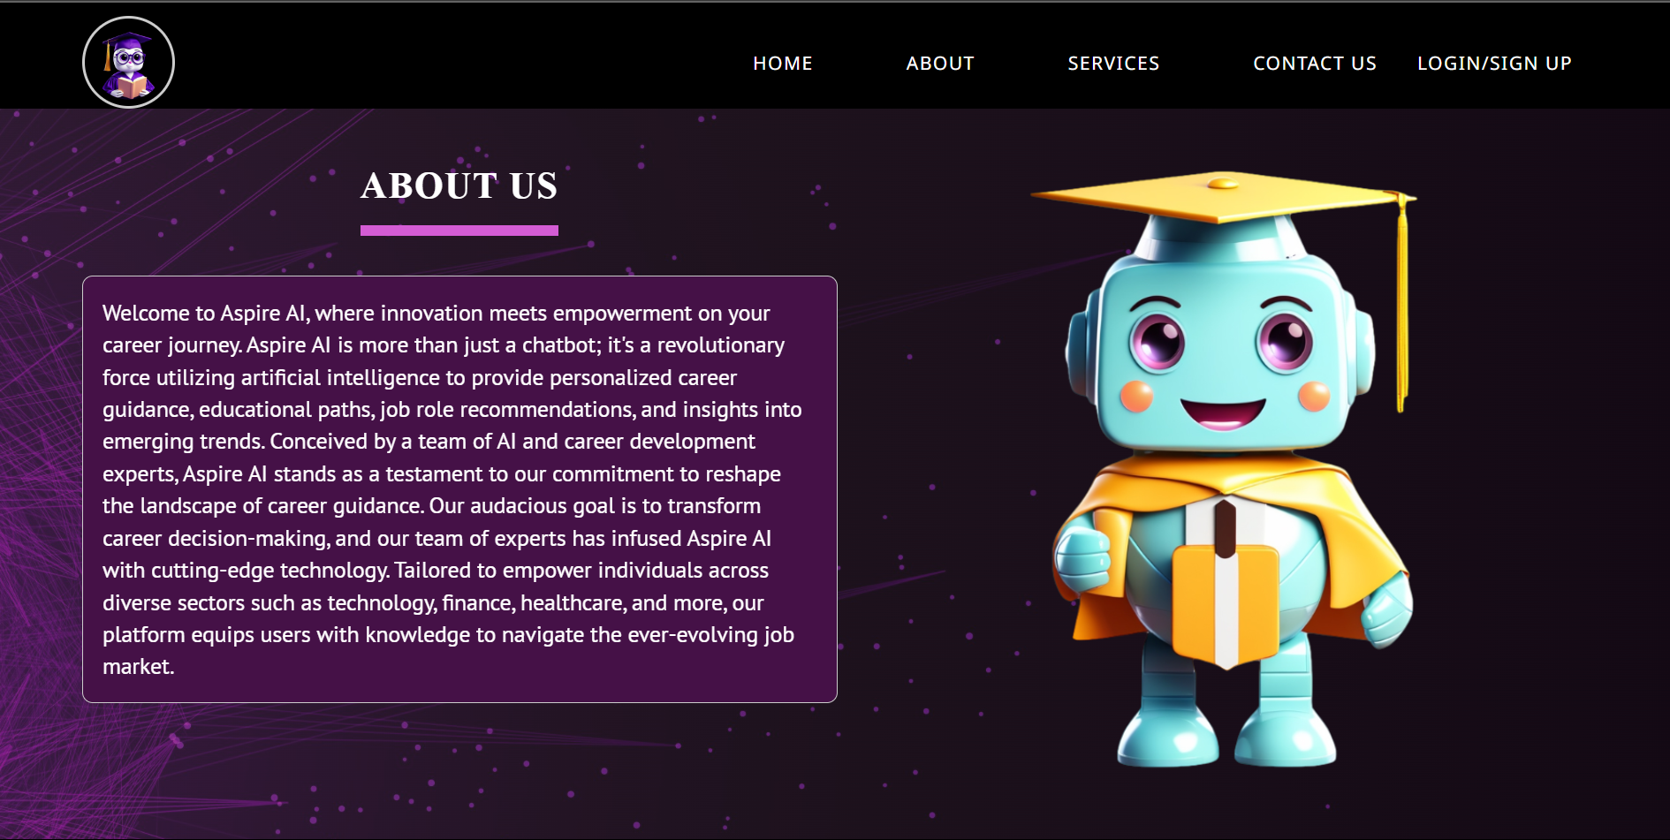

Fig.4: About Us Page

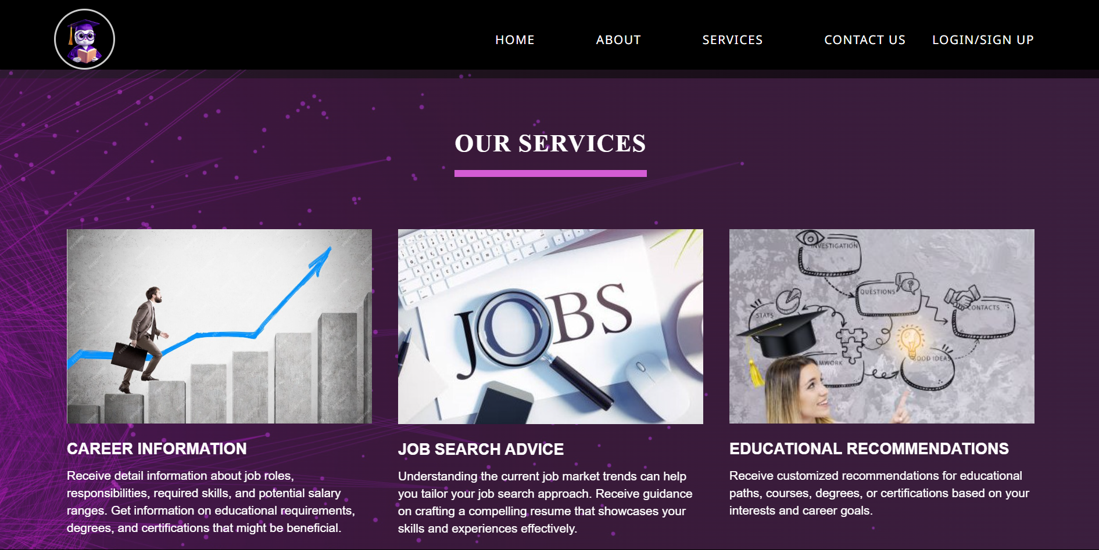

Fig.5: Services Page

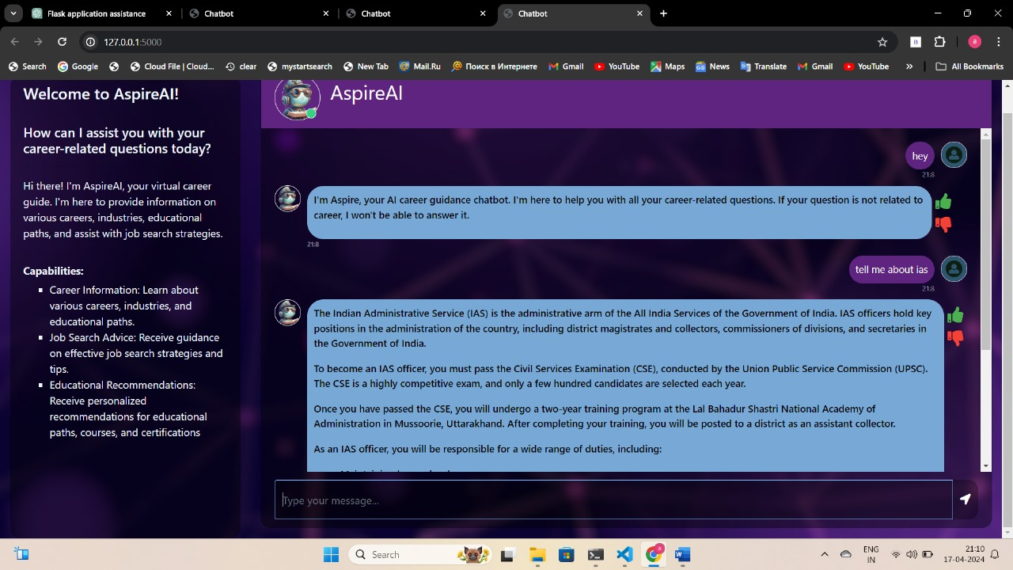

Fig.6: Chatbot Window 1

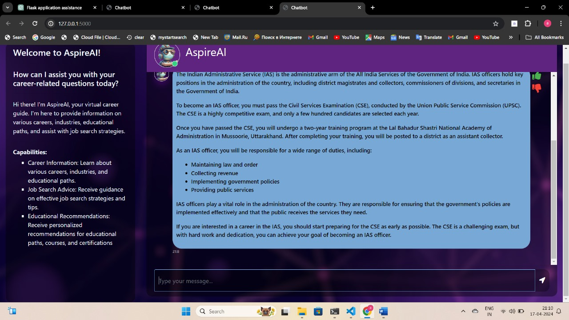

Fig.7: Chatbot Window 2

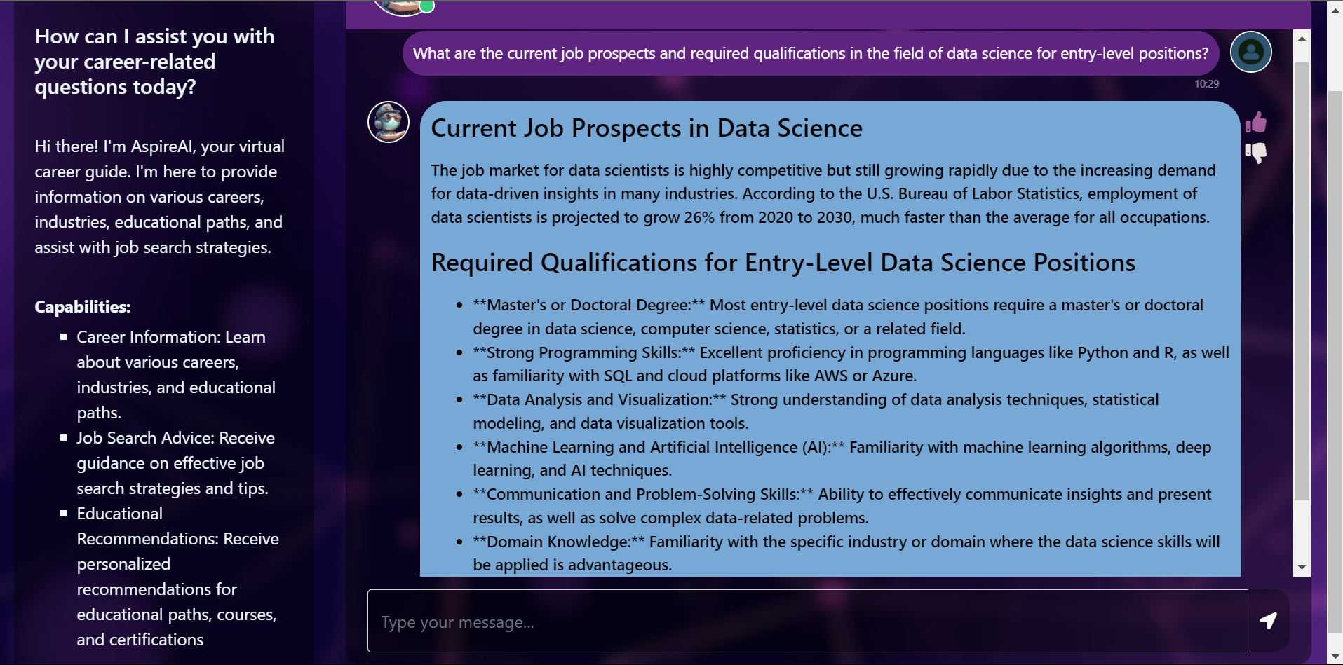

Fig.8: Chatbot Window 3

1. **Conclusion**

We introduced AspireAI, an AI chatbot meticulously designed to provide comprehensive career guidance to users. Leveraging advanced natural language processing techniques and state-of-the-art Large Language Models (LLMs), such as AutoPeftModelForCausalLM, AspireAI demonstrated remarkable effectiveness in delivering personalized career insights, job search advice, and educational recommendations. Through rigorous evaluation, we observed high levels of accuracy, timeliness, and user engagement, affirming the chatbot's significance in facilitating informed career decision-making.

The successful development and deployment of AspireAI underscore the transformative potential of AI-driven solutions, particularly those powered by LLMs, in addressing the complexities of career exploration and advancement. By providing users with clear, precise, and tailored guidance, AspireAI contributes to empowering individuals to navigate the dynamic landscape of the job market with confidence and clarity.

Looking ahead, continued research and development efforts will focus on further enhancing AspireAI's capabilities, refining its contextual understanding, and leveraging advancements in LLMs to expand its knowledge base and improve response accuracy. By harnessing the power of LLMs and artificial intelligence, AspireAI stands poised to revolutionize the field of career counseling, ushering in a new era of personalized guidance and support for individuals seeking to achieve their professional aspirations.

**References**

1. Adam, Martin, Michael Wessel, and Alexander Benlian, "AI-based chatbots in customer service and their effects on user compliance," Electronic Markets 31, no. 2, pp. 427-445, 2021
2. Nuruzzaman, Mohammad, and O. K. Hussain, "A survey on chatbot implementation in customer service industry through deep neural networks." in 2018 IEEE 15th International Conference on e-Business Engineering (ICEBE), pp. 54-61. IEEE, 2018.
3. Parab, Archana, S. Palkar, S. Maurya, and S. Balpande, "An Intelligent Career Counselling Bot A System for Counselling," International Research Journal of Engineering and Technology (IRJET) 4, no. 03, pp. 2325-2330, 2017.
4. Nguyen, D. Cuong, N. H. D. Dinh, C. Pham-Nguyen, T. L. Dinh, and N. H. L. Nam, "ITCareerBot: A Personalized Career Counselling Chatbot," in Asian Conference on Intelligent Information and Database Systems, pp. 423-436. Springer, Singapore, 2022.
5. L. H. Su, T. Dang-Huy, T. Thi-Yen-Linh, N. Thi-Duyen-Ngoc, L. Bao- Tuyen, and N. Ha-Phuong-Truc, "Development of an AI Chatbot to support admissions and career guidance for universities," International Journal of Emerging Multidisciplinary Research 4, no. 2, pp. 11-17, 2020.
6. Smutny, Pavel, and P. Schreiberova, "Chatbots for learning: A review of educational chatbots for the Facebook Messenger," Computers & Education, vol. 151, 2020.
7. Kohli, Bhaumik,T.Choudhury,S.Sharma,andP.Kumar,"Aplatform for human-chatbot interaction using python," in 2018 IEEE Second International Conference on Green Computing and Internet of Things (ICGCIoT), pp. 439-444, 2018.
8. Lee, Terri, T. Zhu, S. Liu, L. Trac, Z. Huang, and Y. Chen, "CASExplorer: A Conversational Academic and Career Advisor for College Students," in The Ninth International Symposium of Chinese CHI, pp. 112-116. 2021.
9. G. Dongre, F. Vadraiwala, J. Upadhyaya, D. Ghosal, "Web-Based Career Counselling System With Chatbot,” International Research Journal of Modernization in Engineering Technology and Science, volume 03, pp. 571-579, 2021.
10. V. Shreeram, N., and A. Muthukumaravel, "Student Career Prediction Using Machine Learning Approaches." In I3CAC 2021: Proceedings of the First International Conference on Computing, Communication and Control System, I3CAC 2021, 7-8 June 2021, Bharath University, Chennai, India, p. 444, European Alliance for Innovation, 2021.